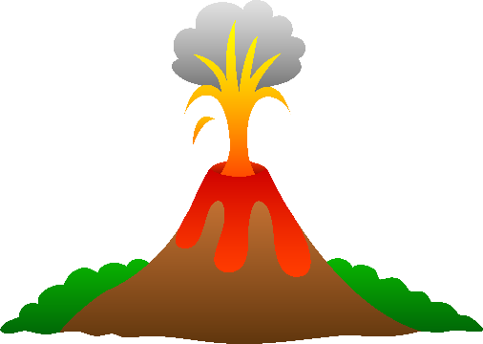

**Natural Disaster Research**

**This assessment consists of two parts. Both are assessed.**

**Part a –** Making your own notes using internet resources.

**Part b –** Using your notes to complete a validation sheet under test conditions.

**Part a.**

**Use library and internet resources to research one of the following events.**

|  |  |  |  |
| --- | --- | --- | --- |
| **Volcanic Eruptions** | | **Earthquakes** | |
| **Date (AD)** | **Volcano & Place** | **Date** | **Place** |
| 79 | Vesuvius, Italy | 1755 | Lisbon, Portugal |
| 1104 | Hekla, Iceland | 1906 | San Francisco, USA |
| 1792 | Unzen, Japan | 1960 | Valdivia, Chile |
| 1815 | Tambora, Indonesia | 1970 | Chimbote, Peru |
| 1883 | Krakatoa, Indonesia | 1976 | Tangshan, China |
| 1902 | Mont Pelee, Martinique | 1985 | Mexico City, Mexico |
| 1973 | Heimaey, Iceland | 1995 | Kobe, Japan |
| 1980 | Mount St Helens, USA | 2004 | Sumatra, Indonesia (and tsunami) |
| 1982 | El Chichon, Mexico | 2008 | Sichuan, China |
| 1983 | Kilauea, Hawaii | 2011 | Tohoku, Japan (and tsunami) |
| 1985 | Nevado Del Ruiz, Colombia |  |  |
| 1991 | Mt Pinatubo, Philippines |  |  |

1. Take notes and summarise your research information to answer the questions below.

**Keep a list of references.**

* 1. *Find an image indicating the location of the disaster on a map.*
  2. *What impact did the disaster have on the biosphere, lithosphere, atmosphere and hydrosphere?*
  3. *What impact did it have on the human population in the area at the time?*
  4. *Briefly summarise how the volcano was formed or how the earthquake occurred.*
  5. *Create a bibliography of the sites used for your research.*

1. While you are researching, write down 5 unfamiliar words, then find their meaning (keep references) and write a definition in your own words to make a glossary.

**You will need to hand in**

* **your point form summary**
* **your bibliography**
* **your definitions**

**Year 9 Natural Disaster Research**

**Marking guide**

**Part A – Research Notes**

|  |  |  |  |  |
| --- | --- | --- | --- | --- |
|  | 1 mark | 2 marks | 3 marks | Score |
| **Notes** | Incomplete information | Whole sentences copied | Used headings and dot points |  |
| **Bibliography** | 2 or less references | 3 or more references | 3 or more references correctly written |  |
| **Glossary** | 1 – 3 words copied, not in own words. | 4 -5 + words copied, not in own words or  3 -5 words in own words | 5 words defined in own words |  |

**Part B – In class validation**

|  |  |  |  |  |
| --- | --- | --- | --- | --- |
|  | 1 mark | 2 marks | 3 marks | Score |
| Location and time | States where **or** when the Natural Disaster occurred | States where and when Natural Disaster occurred |  |  |
| Impact on Earth’s spheres | States impact on 1 sphere | States impact on 2 spheres | States impact on 3 or more spheres |  |
| Impact on humans | Names 1 example of impact on human population | Names multiple impacts or explains 1 impact in detail. | Explains more than 1 impact in detail/ |  |
| What caused the natural disaster? | Limited information on what caused the disaster | Give some information on how the volcano, earthquake, Tsunami was formed and what caused it to occur. | Gives detailed information on the formation and cause of the eruption, earthquake or tsunami |  |

/**20**

**Name _______________________**

**Year 9 Natural Disaster Research Validation Sheet**

**You may use only your own notes to complete this validation.**

Question 1. (0 marks)

What natural disaster are you answering the following question for?

Question 2. (2 marks)

Where and when did the natural disaster occur?

Question 3. (3 marks)

What impacts did the natural disaster have on the different spheres of the earth?

Question 4. (3 marks)

What impacts did the natural disaster have on the human population in the area

at that the time of the natural disaster?

Question 5. (3 marks)

Explain why the natural disaster occurred in this place at that time. Include as much detail as possible in your answer.